Milestone 1

Caleb Horton

College of Science, Engineering and Technology, Grand Canyon University

CST-150: C# Programming 1

Mark Smithers

September 18, 2022

**Inventory Item Properties**

I intend to make this program work as an inventory system for my church’s tech gear (since I manage the multimedia equipment), so some of the fields would be more geared toward that.

* name: string
* size: string (can have standard units, so keep as string; eg: 1/4”, 1/8”)
* type: string (ie: connector type; eg: XLR, jack, coax, VGA, SDI, HDMI)
* length: float
* lengthUnit: string (keep unit separate since lengths would be more common)
* model: string
* brand: string
* inStorage: int (count being held in storage)
* inUse: int (count being used currently for production)
* totalCount: int (there likely isn’t fractional parts of an item, so keep as an integer, and should be inStorage + inUse) (maybe just for display and not on the actual class?)

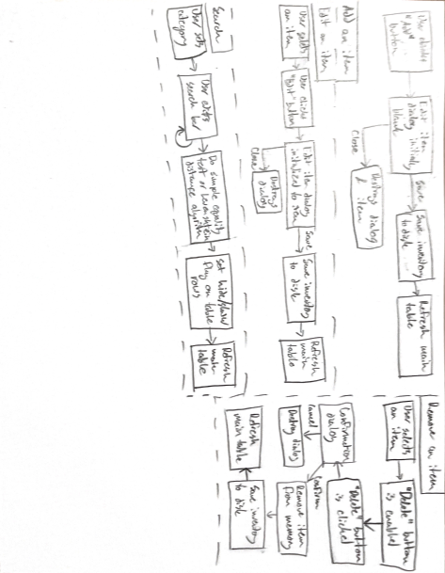

An inventory is a program or system that manages some sort of assorted items, generally keeping track of data like item details (size, shape, make, model, etc.), amount, location, and potentially cost in the case of a store. This would be the software equivalent of walking into a storeroom and writing everything down, except the software should stay in track with the storeroom. One huge advantage of this is that everything should be clearly visible, searchable, and there is no need to go sorting through containers to find a specific item. Also, the inventory can have a history of items, who used them, when they were added/removed, and other useful data pertaining to usage. One of the most critical details for an inventory is the amount; an inventory should be able to have a quick look to see if an item is in stock or is unavailable. For my milestone project, I intend to create an inventory program for my church’s tech (cables, equipment, connectors, etc.) and some of the equipment is kept in unorganized boxes. One huge benefit to me would be knowing exactly what’s in the closet at any time without having to sort through boxes of wires. For a larger business like a hospital or even Amazon, being able to keep track of items and products is a huge task but can be easily handled using technology like an inventory system.